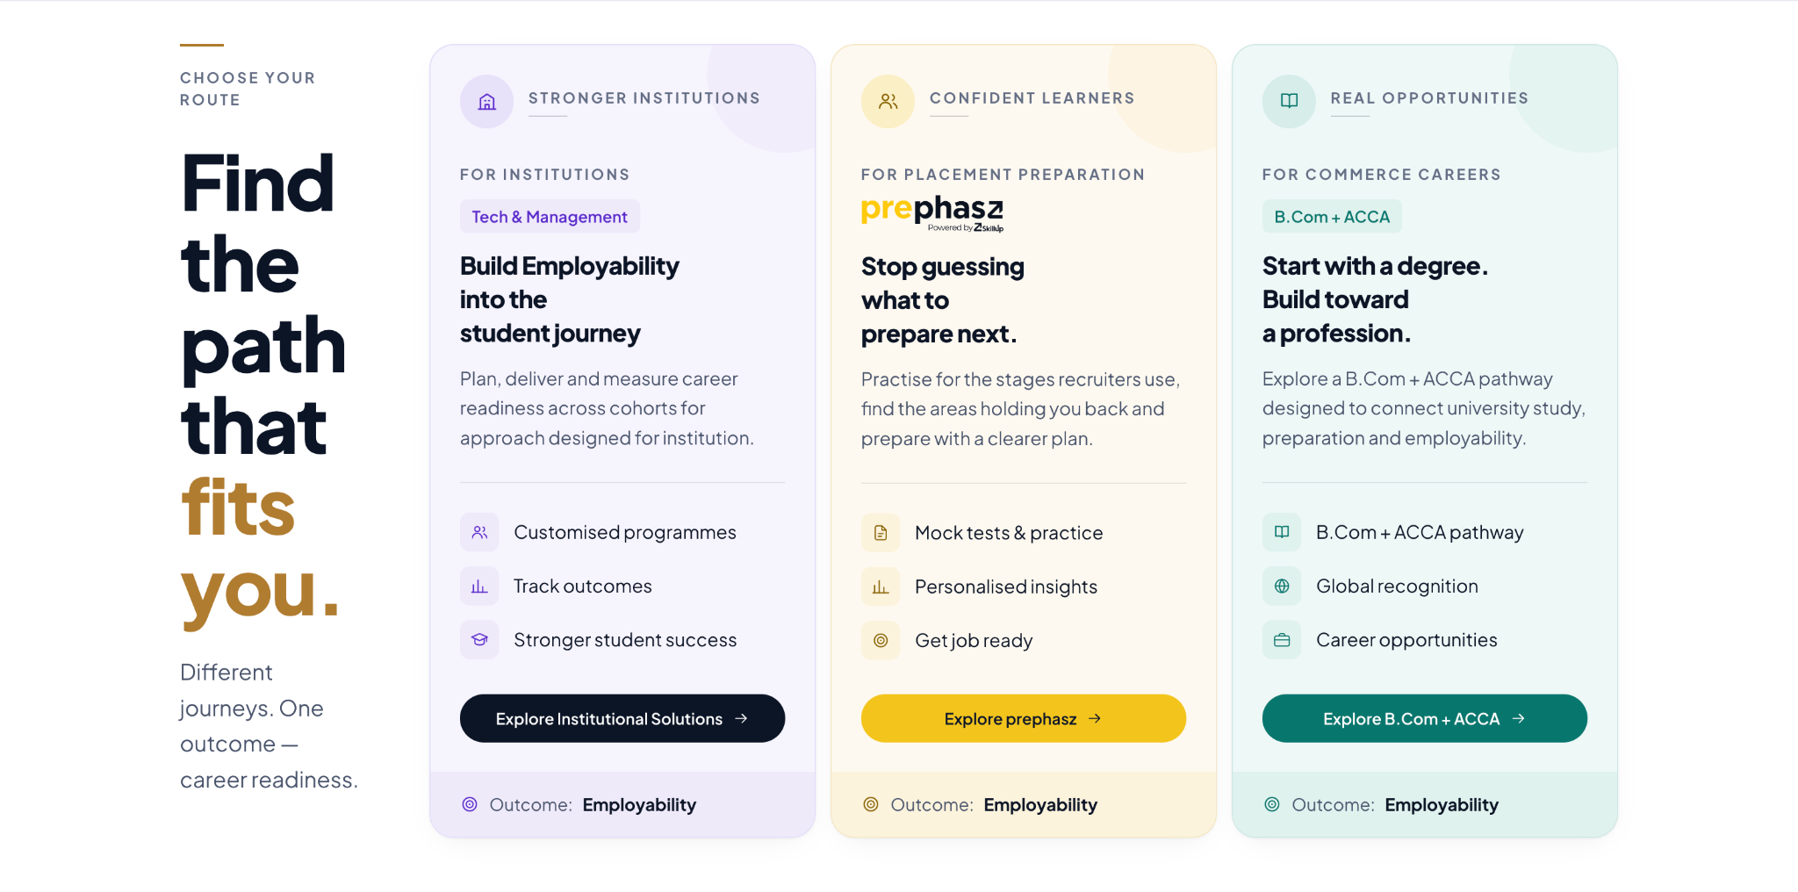
- Chaange 3rd card content
Use B.Com + Global Finance & AI in the small label so it fits the card, and use the full program name in the description.
REAL OPPORTUNITIES
FOR GLOBAL FINANCE CAREERS
B.Com + Global Finance & AI

Future-Ready.
AI-Enabled.
Globally Employable.
Explore the Global Finance & AI Professional Program alongside your B.Com. Build practical finance and AI skills for a changing global workplace.
- B.Com + professional program
- Finance and AI skills
- Global career opportunities
Explore the Program →
Outcome: Employability
- Need to re align the text

- Note
  - If possible, it would be helpful if we could make these small visual/alignment changes together on the call, so we can review and finalise them immediately instead of going through multiple iterations.

